
Dear Applicant,
Thank you for your interest in the Blinn College Physical Therapist Assistant Program! Enclosed you will find program information, including the admissions requirements and a program application guideline.
If you wish to be considered for admission into the program, you must submit evidence of meeting all of the application/admission requirements. It is the applicant's responsibility to ensure that all application information and materials are received by the stated deadlines.
It is highly recommended that you attend an Information Session where you will learn about the application process, the profession of physical therapy, and the Blinn PTA program. Please visit our program website (https://www.blinn.edu/physical-therapist-assistant/index.html) to sign up for a free Information Session.
This document is intended to help guide you through the application process and compile all required documents. There are step-by-step instructions, as well as links to required documents and forms. Please read it in its entirety to ensure you are well-informed of the requirements for application/admission. The actual program application is to be completed and submitted electronically through Microsoft Forms (instructions and link on the next page).
Best wishes in the pursuit of a rewarding career in Physical Therapy through the PTA Program at Blinn College.

Sincerely,
Kelsey Maki, PT, DPT
Kelsey Maki, PT, DPT
Program Director

Steps to apply:
- Apply to Blinn College and receive acceptance. For information on how/where to apply to Blinn College, please visit: https://www.blinn.edu/admissions/steps-to-apply.html
- Send official transcripts from ALL colleges/universities attended (including Dual credit courses) to Blinn College. Instructions on how/where to send transcripts are included on the ‘Steps to Apply’ webpage (link above).
**The Deadline for ALL official transcripts to be received is February 1st each year.
It is the applicant’s responsibility to ensure all transcripts are received by Blinn College prior to the deadline. To check whether your transcript has been received/entered, log in to your MyBLINN homepage and scroll down to select the ‘Your Degree Progress’ icon.
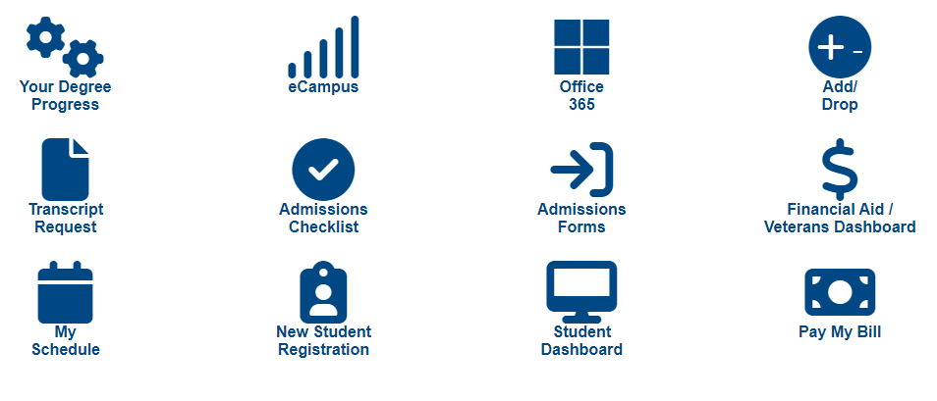
Please allow 1-2 weeks for the Registrar’s office to input all courses/transcripts. If your courses and/or colleges are still not appearing on your degree progress dashboard, please contact the Admissions office at admissions@blinn.edu .
- Complete the PTA Program application through Microsoft Forms. It is mandatory to complete this form using your MyBLINN username & password, as it is most compatible with Microsoft Forms.
The link for the application can be found on the program website. It will open on October 1 and close on March 1 at 11:45 PM CST.
- In addition to the program application, you must also request evaluations from a Licensed PT or PTA at EACH observation experience facility/clinic, as well as 1 additional Non-PT Evaluation. You can complete this form and request evaluations to be sent prior to submitting your overall program application. The applicant must complete the following link to request these evaluations to be sent directly to the evaluators:
See Page 12 of this document for the request form link/QR Code.

Once you click “Submit” on the PTA Program application form, it will automatically be delivered electronically to the program admissions committee. The program will be in contact with you as soon as application scoring has been completed (after March 1st). If you have any questions, please contact the program Administrative Assistant, Victoria Parnell at Victoria.parnell@blinn.edu .

Note: It is not a requirement to be a Pre-PTA major to apply to this program, but it does help expedite the transcript approval process and timeline. If you would like to change your major to Pre-PTA, please contact Kate Karstadt at kate.karstadt@blinn.edu .

APPLICANT INFORMATION
Full Name:
Blinn ID # (B00------)
Date of Birth:
Blinn email address:
Other email address:
Phone Number:
Address:

Have you previously applied to a Blinn College Health Science program? ☐ Yes ☐No
If you answered ‘Yes’, please list the program(s) below:

What is your primary language?
☐English
☐Spanish
☐Other:

HIGH SCHOOL EDUCATION
Where did you graduate from High School? If you did not graduate from High School, but earned your GED, please write ‘GED’.

COLLEGE EDUCATION
Please use the following questions to enter the Name and Location (City & State) of ALL Colleges or Universities you’ve ever attended. (For example: Blinn College – Brenham, TX)
College/University 1:
College/University 2:
College/University 3:
College/University 4:
List the names and locations of any other colleges/universities you’ve attended:

Have you earned any of the following post-secondary degrees? (If you’ve earned multiple degrees, please select the highest degree completed.)
☐Associate degree
☐Bachelors degree
☐Masters degree
☐Doctoral degree/PhD
☐N/A – Degree still in progress
If you selected a degree above, what is the name of the college/university where you completed that degree? (To receive bonus points on the application, this degree must be confirmed by your official transcript.)

GENERAL EDUCATION AND PRE-REQUISITES
The following courses are required prerequisites for admission to the PTA Program. All courses must be completed with at least a “C” or higher to satisfy the requirements of the program degree plan.
Please indicate the status of each of the following courses, as well as grades awarded. If you have taken any of the prerequisite courses more than once, only enter the highest grade earned.
All grades will be verified and must match your official transcripts in order to receive points on the application.
Course | Credit Hours | College/University | Status | Semester & Year Completed | Grade
Example:  PTHA 1201 The Profession of Physical Therapy | 2 | Blinn College | ☒ Complete  ☐ In Progress  ☐ Not Completed | Fall 2023 | A
*ENGL 1301  Composition I | 3 |  | ☐ Complete  ☐ In Progress  ☐ Not Completed
*BIOL 2401  Anatomy & Physiology I | 4 |  | ☐ Complete  ☐ In Progress  ☐ Not Completed
*PSYC 2301  General Psychology | 3 |  | ☐ Complete  ☐ In Progress  ☐ Not Completed
*PTHA 1201  The Profession of Physical Therapy | 2 |  | ☐ Complete  ☐ In Progress  ☐ Not Completed
HITT 1305  Medical Terminology | 4 |  | ☐ Complete  ☐ In Progress  ☐ Not Completed
BIOL 2402  Anatomy & Physiology II | 4 |  | ☐ Complete  ☐ In Progress  ☐ Not Completed
Humanities or Fine Arts Elective (See below for acceptable courses) | 3 |  | ☐ Complete  ☐ In Progress  ☐ Not Completed
*Bolded courses = MUST be completed prior to beginning the PTA Program.
Because admission to the program is highly competitive, students who have completed the remaining 3 prerequisite courses at the time of application are more likely to be accepted and successful in the program. If accepted and you have not completed all courses, you may be required to complete the remaining prerequisites prior to beginning the program in the Fall.
Humanities/Fine Arts electives: ENGL 2322, 2323, 2327, 2328, 2332, 2333; PHIL 1301, 2306;
ARTS 1301, 1303, 1304; DRAM 1310, 2361, 2362, 2366; MUSI 1301, 1306, 1308, 1310

STANDARDIZED TESTING
The Blinn PTA program requires all applicants to take the ATI TEAS Test. The minimum cut-off score is a 65% or higher. If you did not achieve at least a 65% overall score, you must re-take the exam in order for your application to be considered. You may take the exam as many times as you wish, and the highest attempt will be scored on the application.
Please visit the Blinn Health Science TEAS Website for more information about testing:
https://www.blinn.edu/testing/health-sciences-ati-teas.html
In addition to entering your score below, you must also provide a copy of your test score sheet to validate your score.

Enter your test date (highest attempt/score):
Overall Test Score: _____ %

Have you taken the TEAS Test more than one time? ☐Yes ☐No
If you answered ‘Yes’ to the question above, please enter the test information for additional attempt(s).

Additional Attempt #1
Date taken:
Overall Test Score: _____ %

Additional Attempt #2
Date taken:
Overall Test Score: _____ %
PHYSICAL THERAPY OBSERVATION HOURS
All applicants are required to complete at least 20 observation hours in a physical therapy setting. These hours can be paid or volunteer, and can be in any setting (i.e. hospital/acute, outpatient, home health, skilled nursing facility, pediatrics, etc.)
Hours are valid for two years and must be validated by a Licensed PT or PTA signature. The Documentation of PT Experience form can be found on the PTA Program website: https://www.blinn.edu/physical-therapist-assistant/admission.html
*It is highly recommended that all applicants complete observation hours in a variety of settings. Applicants receive bonus points on the application for hours completed in additional settings. In order to receive bonus points for each additional setting, you must complete at least 20 hours in each new setting.
Name of clinic/facility | Location (City, State) | # of hours completed | Documentation of PT Experience Form completed and signed? | PT/PTA contact info included on the Evaluation Request Form?
Example: CHI St. Joseph Regional Hospital | Bryan, TX | 50 hours | Yes | Yes

*I understand that, in addition to entering my hours and uploading my form above, I must also complete the Evaluation Request Form (https://forms.office.com/r/HvFSk6k6dT ) to designate one licensed therapist from EACH facility/observation experience (including additional experiences) to complete an evaluation on my behalf.
☐Yes ☐No

VOLUNTEER/COMMUNITY SERVICE
Applicants may complete volunteer/community service hours for bonus application points. There is not a specific form required to validate hours, but you must upload a document that verifies you've completed the hours (i.e. a letter, time sheet, hour log, etc. with a signature from your supervisor or coordinator).
*If you do not provide proof of completion of hours, you will not receive bonus points on the application.
If you have not completed community service hours, skip this section.
Name of community service event/organization | Location (City, State) | # of hours completed | Proof of hours obtained?
Example: The Big Event | College Station, TX | 8 hours | Yes – Letter from coordinator

CERTIFICATIONS AND LICENSES
Applicants may receive bonus application points for other healthcare-related licenses and/or certifications. Examples of certifications/licenses include: CPR/AED, First Aid, EMT, Paramedic, CPT, LMT, ATC, CNA, etc.
Other certifications/licenses that are relevant to healthcare or patient care may be submitted for consideration.
You must upload a copy of all CURRENT (not expired) certifications for proof in order to receive bonus application points.
If you do not have any certifications/licenses to upload, skip this section.
Certification or License | Issuing entity | Valid and active (not expired)? | Copy of certification or license?
Example: CPR & AED Certificate | American Heart Association | Yes | Yes

PROGRAM QUESTIONS
- What are your short-term and long-term goals?
- What are your strongest characteristics? Weakest characteristics?
- What motivated you to pursue a career as a Physical Therapist Assistant?
- Describe your personal qualities that would contribute to your success as a Physical Therapist Assistant.
- In the event that you are not selected for this program, what is your alternate plan?

PTA PROGRAM EVALUATION REQUEST FORM:
This form is required to be completed by the applicant for all recommendations for the PTA Program application.
Applicants must submit the name and email address for one licensed therapist (PT or PTA) for EACH observation location. There are a maximum of 4 slots to enter PT/PTA evaluator(s).
Additionally, you must also submit the name and email address for ONE individual to complete a Non-PT evaluation. This should be someone who has observed you in a professional capacity, not affiliated with the physical therapy profession. This evaluation can be completed by a professor, supervisor, mentor, community service coordinator, etc. (NO family or friends)
Once you submit this form, within 24-48 hours, an email will be generated to each of the individuals you submitted. Please let them know to expect this email from pta@blinn.edu . If the evaluator does not receive the form, please advise him/her to check the Junk folder. If the email is still not received, please email Victoria Parnell (Victoria.parnell@blinn.edu ) to request the form to be sent again. Once the evaluator completes an evaluation, it will automatically be submitted to the PTA Program admissions committee.
It is the applicant’s responsibility to communicate with evaluators and ensure evaluations are completed and submitted.
Scan the QR Code or Click the URL link below to access the request form:
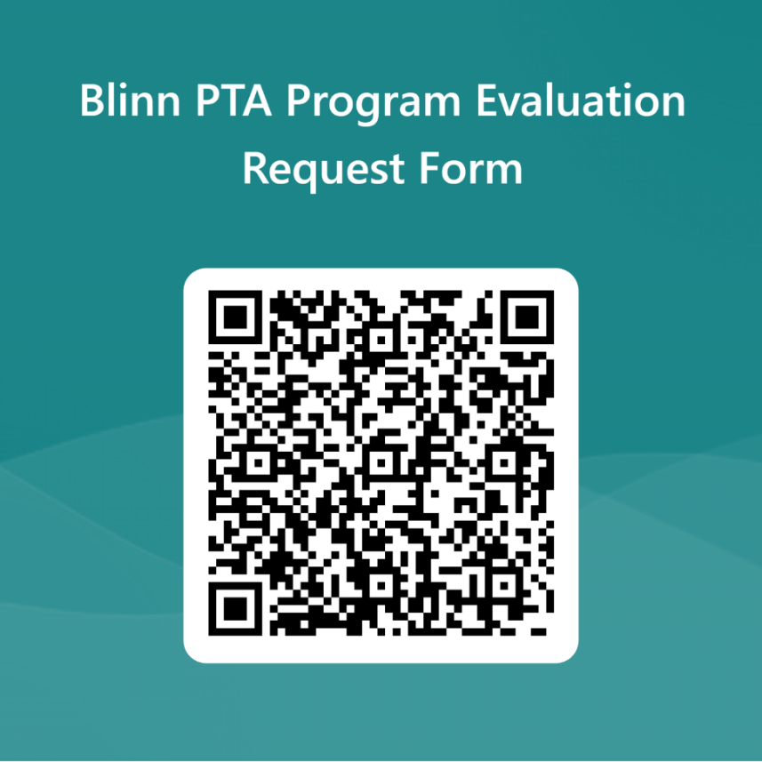
https://forms.office.com/Pages/ResponsePage.aspx?id=hYpEYAfQV02lg7_smOmcKWAyGI4mzyNGnRlNQHF3uxxUNFZZM0swUjNXTVpDUjNBOEw1TzJVUDZLRS4u

